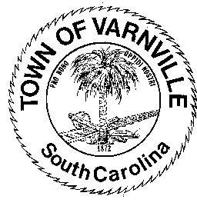

Employment Opportunity

The Town of Varnville is seeking a General Services Technician. The position performs routine manual and semi-skilled utility and maintenance work in all aspects of municipal government operations including garbage, litter, animal control, landscape and grounds beautification. A valid SC driver’s license is required. The town will provide the opportunity to obtain a CDL within a reasonable probational period. A successful candidate must be drug free and have a good rapport. Salary is negotiable based on qualifications and experience. We offer excellent retirement, health, wage benefits, and a good work environment. Submit application to; Shannon Shaffer, admin@varnville.sc.gov; 95 E. Palmetto Ave. Po Box 308, Varnville, SC 29944. Ph: 803-943-2979; Additional inquiry contact Amy Priest 803-942-4699

